**Recipe Application for Tons of Food for U (T.O.F.U)**

Nilesh Shrestha

B.Sc. (Hons.) Computing, Softwarica College of IT and E-commerce, Coventry University

ST4008CEM Computing Activity Led Learning Project 1

Giriraj Rawat

February 21, 2023

**Table of Contents**

Introduction 3

Recipe Application Page 4

Create Recipe 6

View Recipe 8

Update Recipe 10

Delete Recipe 13

Search Recipe 15

Version Control 17

Conclusion 18

**Table of Figures**

Figure 1: Recipe Application UI 5

Figure 2: Code for Recipe application UI design 6

Figure 3: Code for creating recipes 8

Figure 4: recipe application displaying recipe details 9

Figure 5: Code for how viewing recipe works with function getMyRecipe. 10

Figure 6: Recipe application page when you select the recipe and press the “update recipe” button 12

Figure 7: Code updating the recipe 13

Figure 8: Recipe Application when a recipe is deleted 14

Figure 9: Code for how the deleting recipe works. 15

Figure 10: result when the recipe does not exist 16

Figure 11: search results when the recipe exists in the database. 17

Figure 12: Code for searching a recipe 17

Figure 13: GitHub Commits 18

# Introduction

The recipe application is designed to help users manage and organize their recipes in a systematic and a user-friendly manner. The objective of project is to create a simple and a user-friendly application for its users, using python tkinter library while following agile methodology of SDLC.

The recipe application integrated with database using SQLite allows the user to perform basic CRUD (Create, Read, Update and Delete) on their recipes, add new recipes, view existing ones, edit them or delete them as required. Additionally, the search function allows the users to search for any existing recipes in the database based on their names.

Overall, the application is designed to provide a convenient, user-friendly interface for users to store and manage their data efficiently as well as access them easily.

# Recipe Application Page

The recipe application page is the central hub of the system. This page was designed to provide the users intuitive and efficient way to manage their recipe data.

On this page, users, can access their personalized recipe database, view and edit the existing recipes, add new recipes and delete the old ones. It also includes a search bar to allow the users to quickly locate their recipes and save time and effort.

Overall, the recipe application page is designed to provide its users with a very simple and efficient way to manage their recipe.

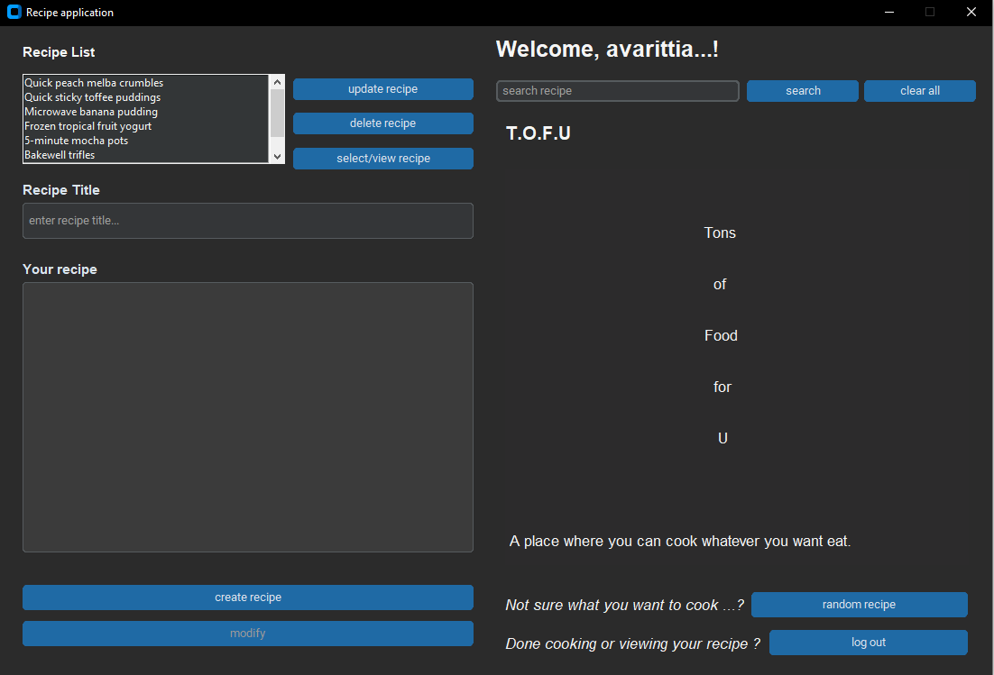

### Figure 1: Recipe Application UI

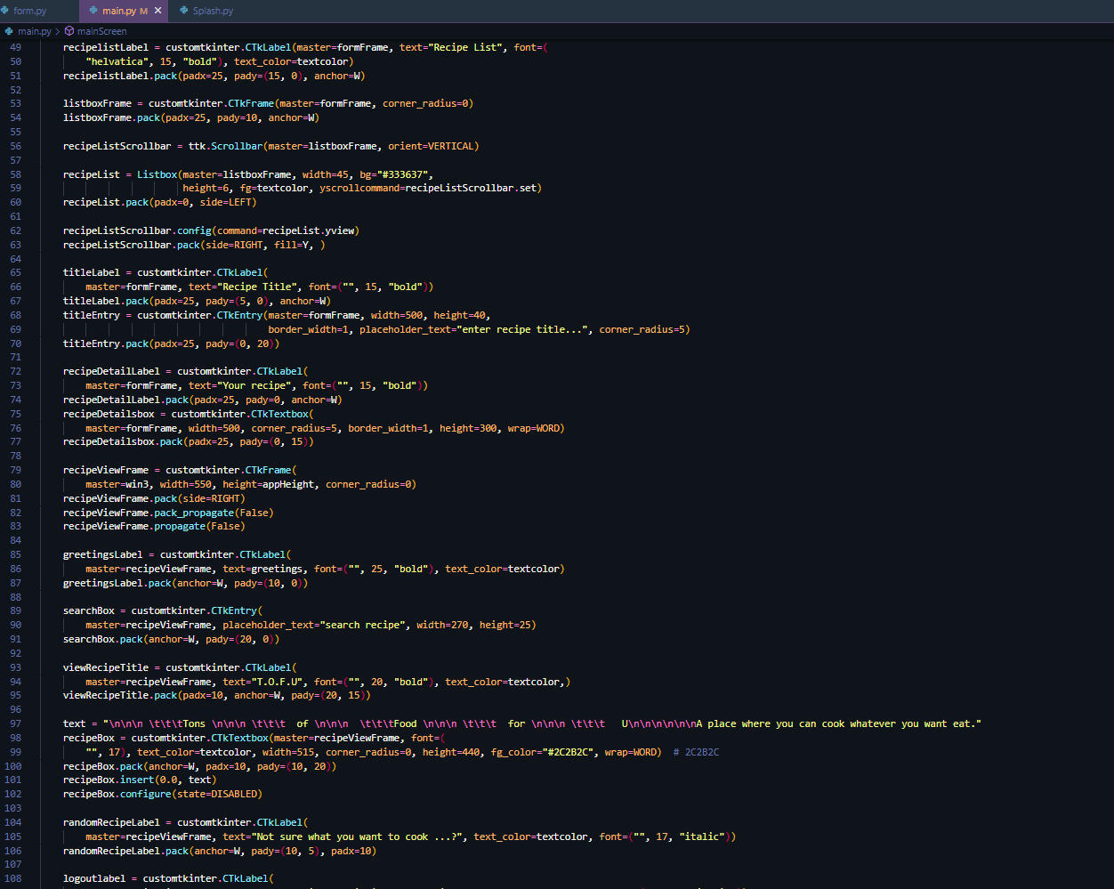

### Figure 2: Code for Recipe application UI design

# Create Recipe

To create recipe the application, the user simply needs to input the recipe title and recipe details in the form, with any other necessary information such as cooking time, preparation steps, ingredients.

The user can then press “create recipe” button, which will add the recipe to their personalized database and will be available for them to view, delete and edit on the main application page.

Creating recipe is a very straight forward process that is designed to be user-friendly. The system is optimized to make it easy for the users to store, organize and manage their recipe collection. As you can see in Figure 1, how the list of recipes are stored and displayed after creation.

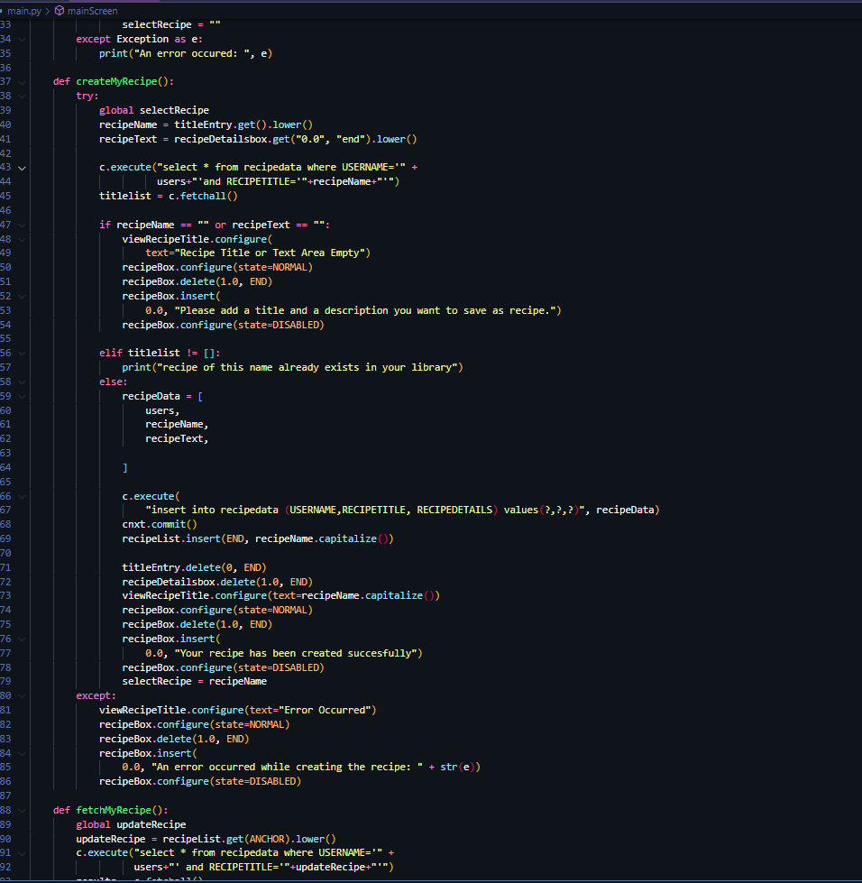

### Figure 3: Code for creating recipes

# View Recipe

To view recipe, the user needs select the recipe from their personalized list of recipes and click on the “view recipe” button. Ones the user selects the recipe, the application will display the recipe details and the title, including any other relevant information.

View recipe is a very quick and easy process that is designed to provide users with all the information about their recipes. The systems interface is optimized to make it easy for user’s to find and view their recipes in a readily accessible way.

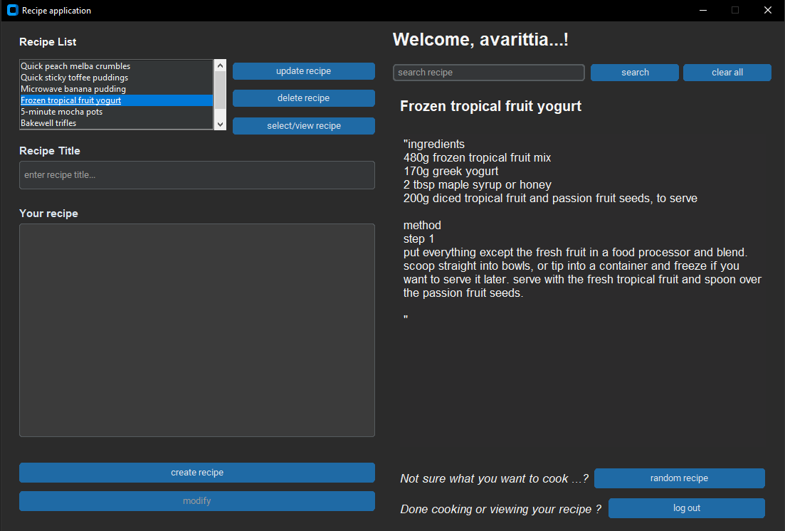

### Figure 4: recipe application displaying recipe details

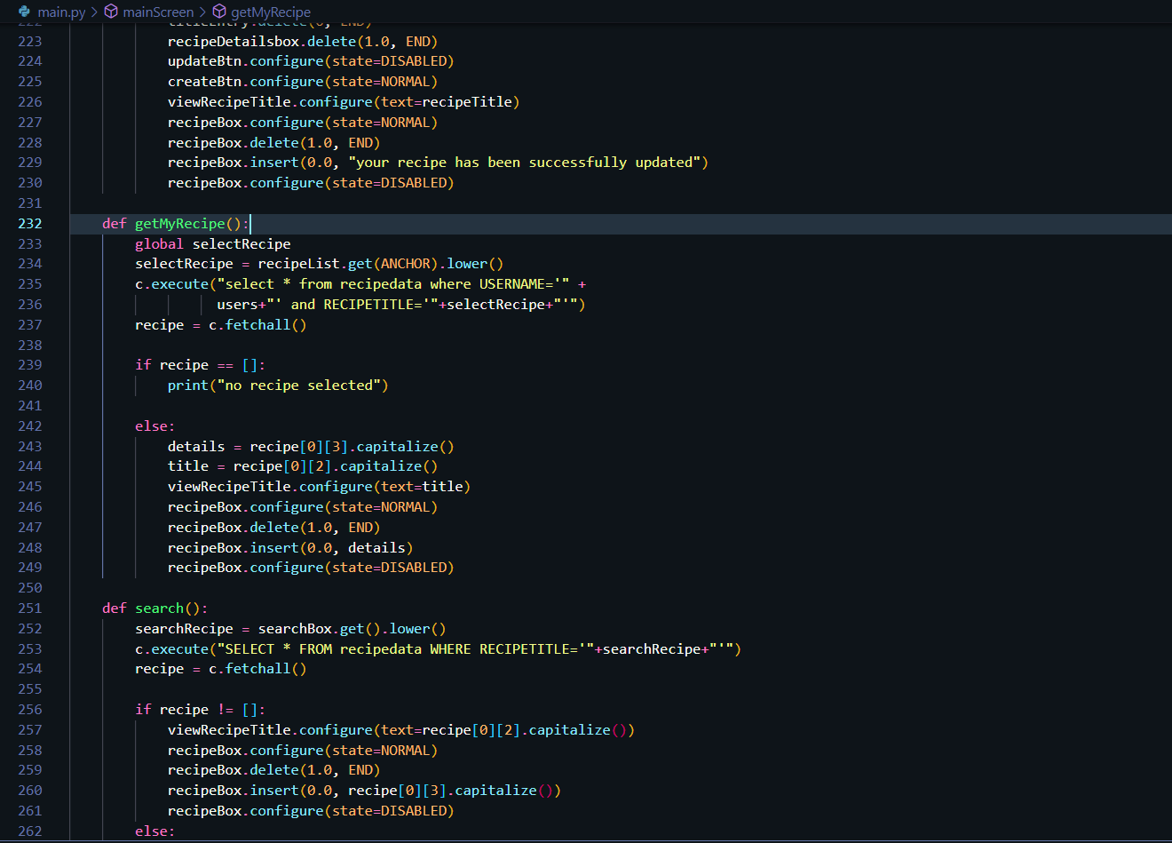

### Figure 5: Code for how viewing recipe works with function getMyRecipe.

# Update Recipe

To update a recipe in the application, the user first and foremost must have at least one recipe on his or her list of recipes in the personalized database. From the list they need to select the recipe they want to update from the recipe list and click on the “update recipe” button. This will prompt the system to insert the recipe title and the details form on the recipe application automatically and allow the users to modify their recipes and at the same time enable the previously disabled “modify” button used to confirm the update of the recipe as well as disable the “create recipe” button to prevent the duplication of the same recipe multiple times

Once the user has finished making changes to their recipes. They can click on the “modify” button to save the changes that they made. This will disable the “modify” button upon the successful update and again enable the “create recipe button”.

Updating recipe is a very simple process designed to be quick and easy for the users.

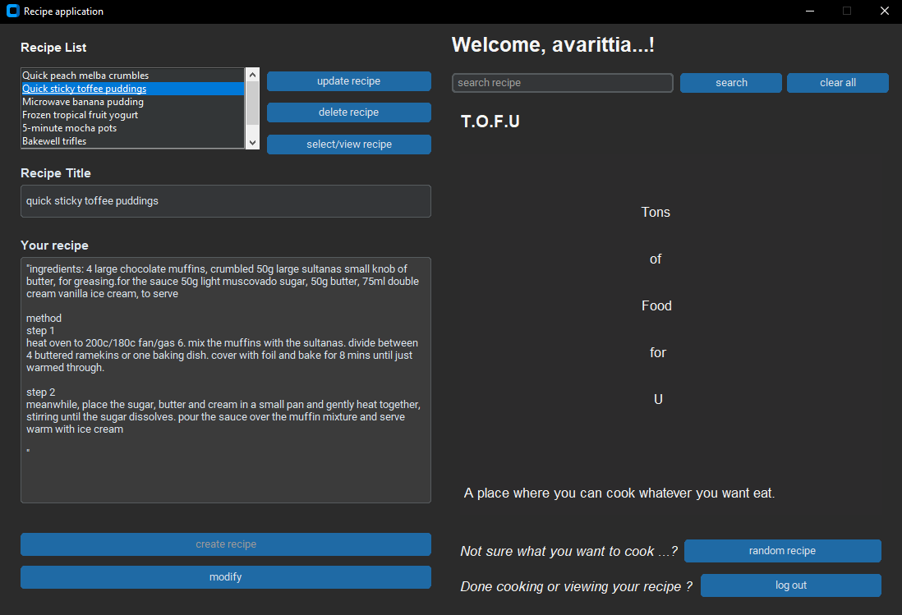

### Figure 6: Recipe application page when you select the recipe and press the “update recipe” button

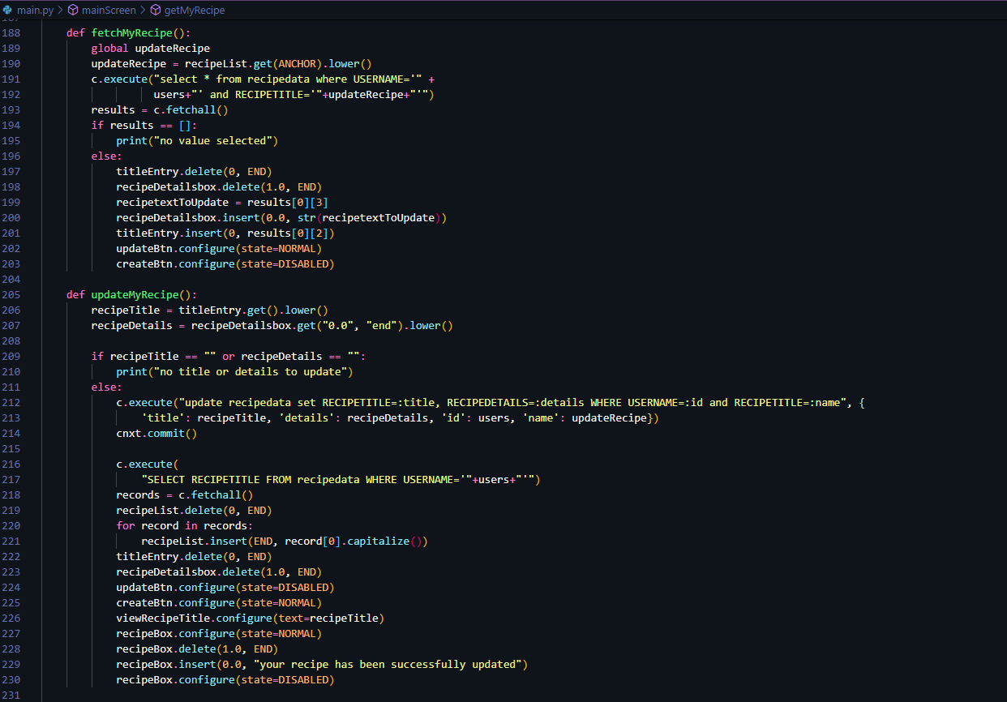

### Figure 7: Code updating the recipe

# Delete Recipe

To delete the a recipe all the user needs to do is to select the recipe they want to delete from their personalized list of recipes and click on the “delete button”. This will remove the selected recipe from the user’s list of recipes and the database entirely. It is important to note that once a recipe is deleted, it cannot be recovered, so the user should exercise caution when deleting recipes.

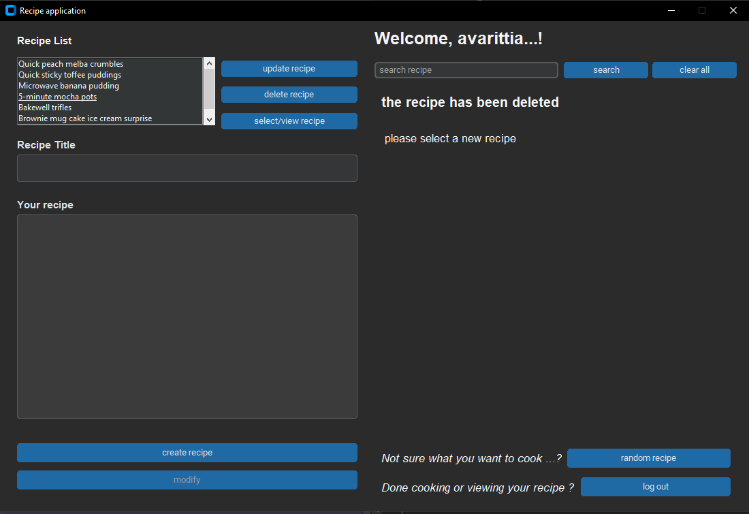

### Figure 8: Recipe Application when a recipe is deleted

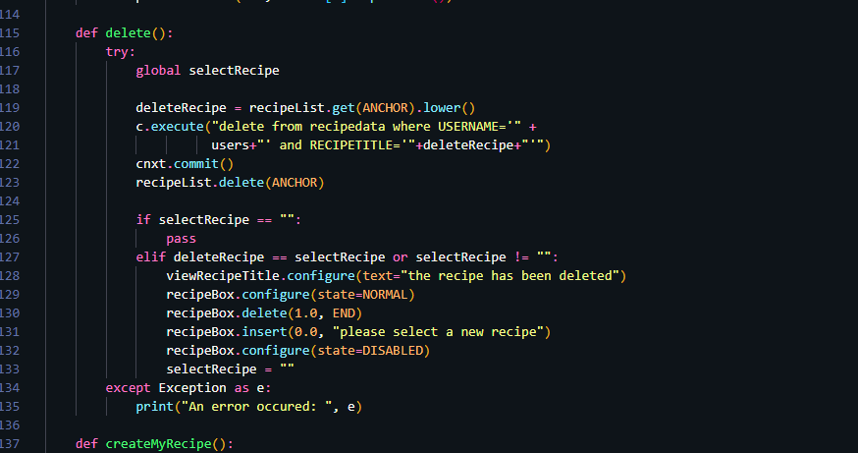

### Figure 9: Code for how the deleting recipe works.

# Search Recipe

To search a recipe in the application, the user needs to navigate to the search bar and enter the name of any recipe that they want to search for from the data base. After clicking entering the desired recipe name on the search bar and clicking “search” button, if the recipe exists in the database, it’ll display the recipe title and its details, if not it will display an error message letting the user know that the database does not have the recipe they are searching for.

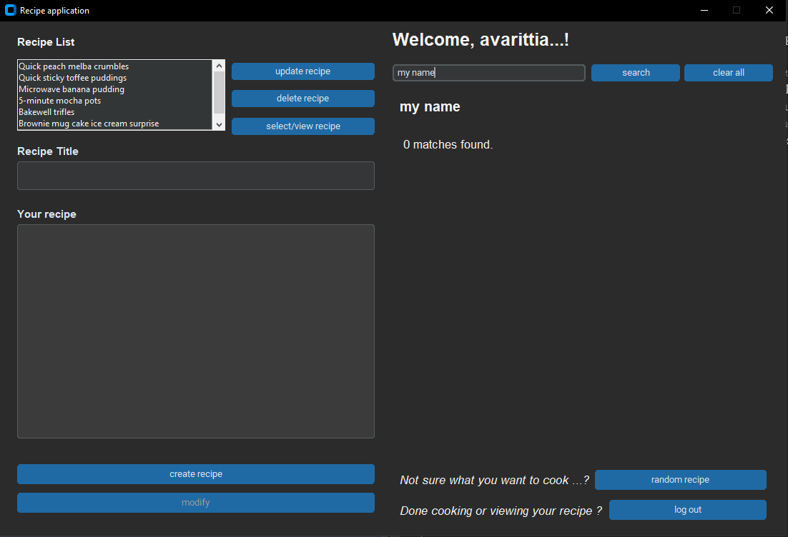

### Figure 10: result when the recipe does not exist

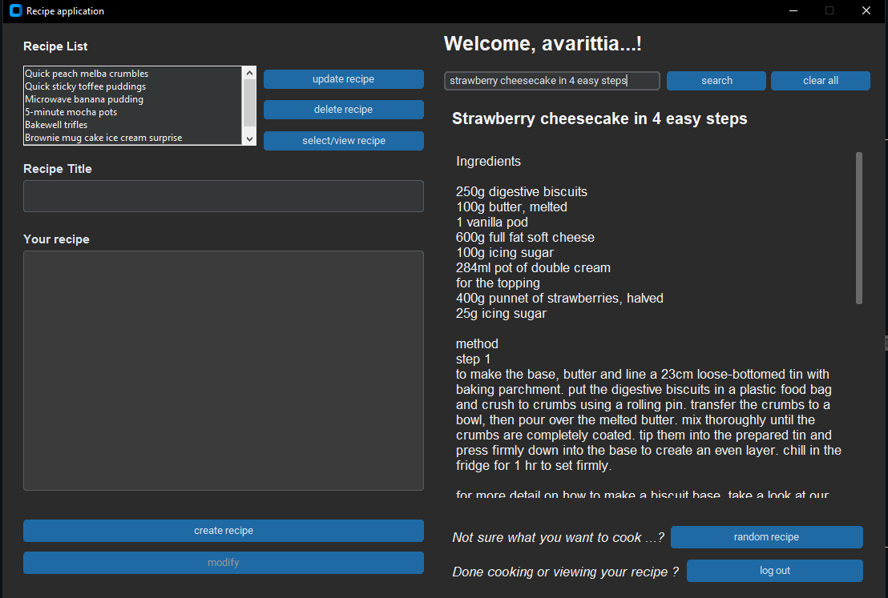

### Figure 11: search results when the recipe exists in the database.

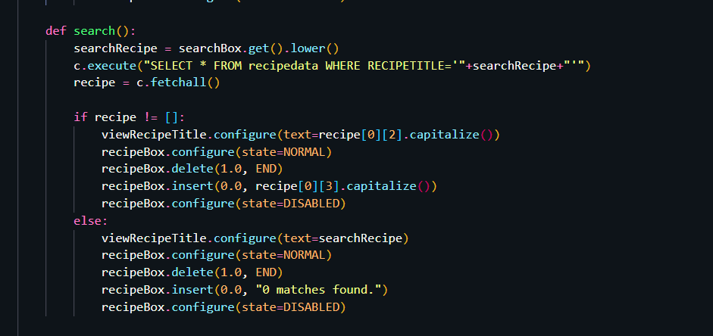

### Figure 12: Code for searching a recipe

# Version Control

**GitHub:** [**https://github.com/nileshshrs/recipe-app-tkinter.git**](https://github.com/nileshshrs/recipe-app-tkinter.git)

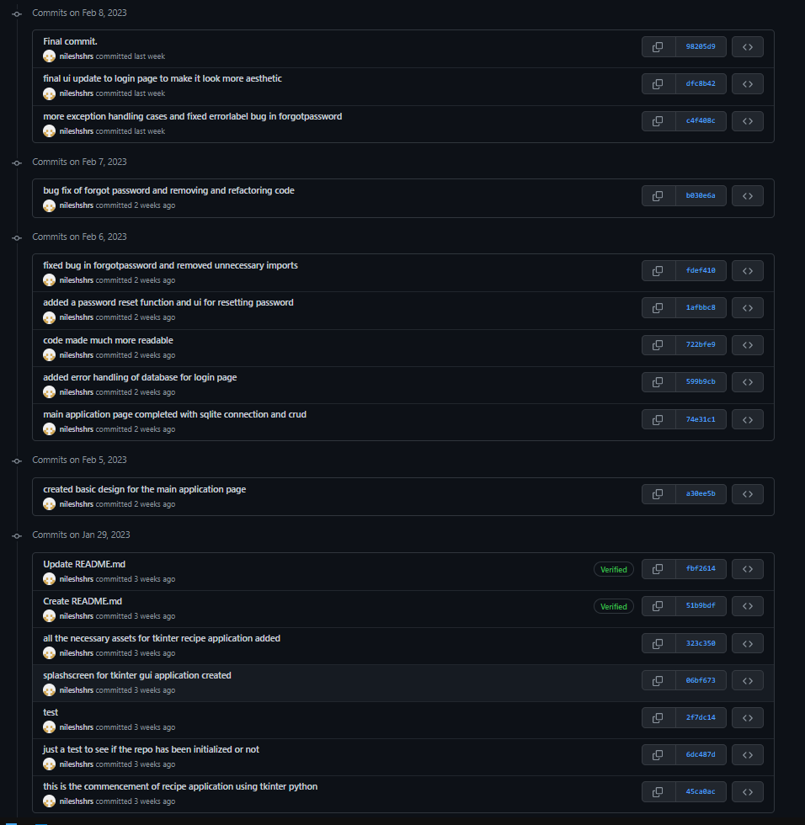

### Figure 13: GitHub Commits

# Conclusion

In conclusion, the development of this recipe application was an excellent collaboration and a good example of teamwork among the members of this school project. Each team member contributed their skills and knowledge to create a very user-friendly application for recipe management.

The project allowed us to apply the concepts we learned in our studies, including frontend development using tkinter (GUI Library) of python, backend development and database connectivity. Through out this project, we gained valuable experience working in a team, managing timelines, addressing unforeseen challenges that arose during development.

The recipe application gave us an opportunity to develop our problem-solving skills, as we worked together to create an application that meets the needs of our target audience. We learned to communicate effectively and work collaboratively to deliver a product that met users’ needs and expectations.

Overall, the development of this application was great learning experience for all of us as we learnt a lot from each other while creating this application which can be useful in our daily lives.